Service - Oligonucleotides

Technical Information
GeneCust provides oligonucleotides of the highest quality, matching all research needs. Our Oligonucleotide Synthesis Service offers custom synthesis of high-quality oligonucleotides in a variety of scales and formats, including a broad range of modified oligos and purification levels.

How does this work ?
Oligonucleotides are chemically synthesized using phosphoramidites. A phosphoramidite is a normal nucleotide with protection groups added to its reactive amine, hydroxyl and phosphate groups.
Raw materials
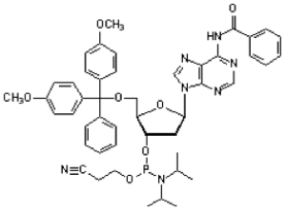 | 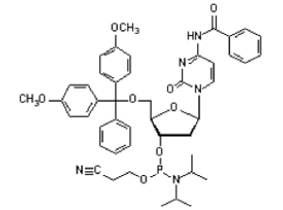
dA(bz) Phosphoramidite | dC(bz) Phosphoramidite
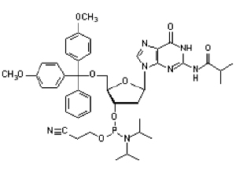 | 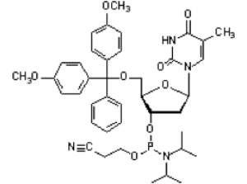
dG(bz) Phosphoramidite | dT(bz) Phosphoramidite
These protection groups prevent unwanted side reactions and force the formation of the desired product during synthesis. The 5' hydroxyl group is protected by DMT (dimethoxytrityl), the phosphate group by a diisopropylamino (iPr2N) group and a 2-cyanoethyl (OCH2CH2CN) group. The bases also have protection groups on the exocyclic amine group (benzoyl or isobutyryl). With the completition of the synthesis process, all the protection groups are removed.
In solid-phase synthesis, the 3' end of the oligonucleotide is bound to a solid support column on which all reactions take place. The 3' group of the first base is immobilized via a linker to a solid support (polystyrene beads or similar). This allows for easy addition and removal of reactants. In each step, the solutions with the nucleotides for the next reaction are pumped through the column from an attached reagent delivery system and washed out before the next nucleotide is added. At the end of the synthesis program, the oligonucleotide is cleaved off the solid support and eluted from the column.
The synthesis cycle
Oligonucleotide synthesis is done via a cycle of four chemical reactions that are repeated until all desired bases have been added:
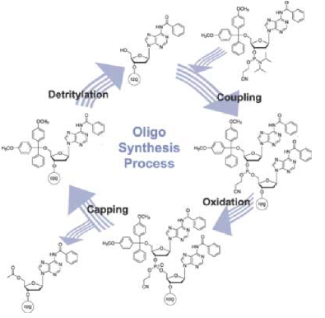
• Step 1 De-blocking (detritylation): The DMT is removed with an acid, such as TCA (Tri Chloro Acetic Acid), and washed out, resulting in a free 5' hydroxyl group on the first base.
• Step 2 Base condensation (coupling): A phosphoramidite nucleotide (or a mix) is activated by tetrazole which removes the iPr2N group on the phosphate group. After addition, the deprotected 5' OH of the first base and the phosphate of the second base react to join the two bases together in a phosphite linkage. These reactions are not done in water but in tetrahydrofuran or in DMSO (Dimethylsulfoxid). Unbound bases and by-products are washed out.
• Step 3 Capping: About 1% of the 5' OH groups do not react with the new base and need to be blocked from further reaction to prevent the synthesis of oligonucleotides with an internal base deletion. This is done by adding a protective group in the form of acetic anhydride and 1-methylimidazole which react with the free 5' OH groups via acetylation. Excess reagents are washed out.
• Step 4 Oxidation: The phosphite linkage between the first and second base needs to be stabilized by making the phosphate group pentavalent. This is achieved by adding iodine and water which leads to the oxidation of the phosphite into phosphate. This step can be substituted with a sulphorylation step for thiophosphate nucleotides.
After accomplishing the synthesis, 2 post-processing steps are required. At first, the oligo must be cleaved from the solid support by treating the support-bound oligonucleotide with concentrated ammonia solution. Secondly, the protecting groups have to be removed from the adenine, guanine and cytidine bases and to release the exocyclic amino function, the ammonia oligonucleotide solution is incubated at higher temperatures (usually between 50°C and 80°C for 1 to 8 hrs. depending on the protocol and protecting groups used).

Purification
The selection of the purification method depends on the type of oligonucleotide and on your purity and yield requirements. There is a trade-off between purity and yield: the higher the purity, the smaller the yield and the lower the purity, the higher the yield.
Reverse-phase cartridge purification
Purification with reverse-phase cartridge offers the lowest level of purity (typically 80%). The basis of the separation is the difference in hydrophobicity between full length product with DMT protecting groups and truncated sequences (without DMT groups).
Because the differences in hydrophobicity between the full length- DMT product and non-DMT truncated sequences are reduced as the oligo length is increased, cartridge purification is not recommended for oligos < 50 bases.
HPLC Reverse-phase purification
Reverse-phase HPLC operates on the same principle as the reverse-phase cartridges, but typical yields a product of 90% purity. The capacity and resolving properties of HPLC columns are also much greater than cartridge devices, so HPLC is the method of choice for purifying larger quantities of oligos (> 1 µmol). As with cartridges, reverse-phase HPLC is usually not recommended for purifying oligos longer than 50 bases.
Polyacrylamide Gel Purification (PAGE)
Purification by this method is considered as the Gold Standard for oligonucleotide purification and yields 95-99% purity. Gel purification can be used for any length of oligonucleotide. Gel purification is strongly advised for all applications involving cloning of the product, such as mutagenesis and gene construction applications. Yields from PAGE are lower than from other methods due to the relative inefficient extraction of oligos from the gel.

Calculations: how to estimate the required scale ?
Oligonucleotides are ordered by scale instead of quantity. In fact, every oligonucleotide is a unique molecule, with unique synthetic properties based on sequence and modifications. That's why the yields of synthesis can be different from one order to another and it can be reported in different units of mass such as milligrams or grams, in mole or in OD. You are the one who decides which scale should you request in order to obtain sufficient quantities?
How is yield measured?
All oligonucleotides are measured for yield using absorbance. UV spectroscopy is a much more accurate way to measure the yield of oligonucleotides since it ignores salt, water, and other residuals of the synthesis that would affect the weight. The oligonucleotide is dissolved in water or buffer and the absorbance at 260 nm determined.
Conversions
OD260 units can be converted to mmoles using Beer's Law that relates absorbance to concentration using the extinction coefficient (?), which is a constant and unique to every substance:
Beer's Law: Absorbance=[concentration].ε can be derived to: [concentration] = Absorbance/ε
The units of ? are (OD260 units)(mL) (µmole)-1, the units of concentration are (µmole)(mL)-1, and absorbance is expressed in OD260 units. The ? is calculated for each and every oligonucleotide. Different formulations exist for this calculation. The most accurate method is to generate the ? experimentally, but this is a very long and difficult process. So, another solution is to use what is called the nearest neighbour model. In a good approximation it corresponds to the sum of the extinction coefficients (?) of the individual nucleotides in the sequence. Using the oligo's sequence data and the OD value one can calculate the concentration and the quantity of material as follows:
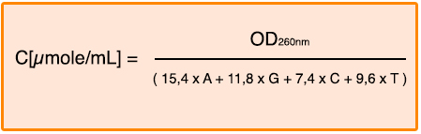
A,G,C,T: number of bases in the oligonucleotide
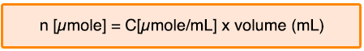
If you wish to determine the mass of the oligonucleotide, multiply the number of moles by the molecular weight:
The molecular weight of an oligonucleotide is calculated from the number of individual nucleotides in the oligonucleotide and from possible modifications of the oligonucleotide:
MWoligo = 313,2*A + 329,2*G + 289,2*C + 304,2*T + MWmod - 61*(g/mol)
A,G,C,T: Number of bases in the oligo
MWmod: Molecular weight of a modification, if present
What affects the yield of your oligonucleotide?
The amount of product theoretically possible from any particular synthesis is determined by the quality of the synthesis itself done on an automated synthesizer. The coupling efficiency of the synthesis is very important. This is easily demonstrated by calculating the theoretical yield with the following formula:
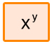
Where X is the average coupling efficiency and y the number of couplings. For example, a synthesis of a 30mer (which requires 29 couplings) with an average coupling efficiency of 99% theoretically yields 75% of product (0.9929). That same synthesis at 98% efficiency will have a maximum yield of only 55%. The following graph represents the synthesis yield with an average coupling efficiency of 98,5%.
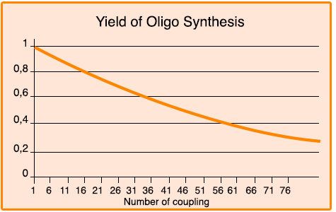
Many factors can influence the coupling efficiency, such as the moisture content in the acetonitrile and phosphoramidite quality. The weather plays a role, as well. Extremely humid days will adversely affect the quality of synthesis by making near complete water removal almost impossible, despite using rigorous anhydrous chemistry techniques. The side reaction can also result to a loss of yield.
Depending on the quality of the synthesis, purification can be the step where the most yield is lost. A high quality synthesis will have only a moderate amount of impurities to remove, allowing a larger cut of the product peak. Moderate and poor syntheses will have more contaminating fragments that will crowd into the product peak, requiring a tighter cut to obtain an acceptable purity. Regardless of the quality of the synthesis, the overall process of purification is costly to yield.
Nevertheless, independently of all these difficulties, GeneCust guarantees a minimum yield for non-labelled, standard oligos, up to 30 bases :
- * 10 nmol scale: 4,5 nmoles
- * 40 nmol scale: 20 nmoles
- * 200 nmol scale: 95 nmoles
- * 1000 nmol scale: 400 nmoles

Quality Control
A stringent quality control system ensures that you can expect the quality of our oligonucleotides to be of the highest standard. Before the synthesis, all chemicals are checked to meet our quality standard. During the fully automatic oligo synthesis, all steps of the synthesis are monitored by multiple control functions on the DNA synthesizers. This way we can assure the coupling efficiency of the synthesis to meet our demands.
The oligonucleotides are subsequently deprotected, desalted, and the optical density is measured at 260 nm. In addition, oligos are randomly analysed by gel electrophoresis and each oligonucleotide will be controlled by the measurement of the molecular mass. All the oligos showing a bad / poor MS profile will be re-synthesized at the expense of GeneCust.

Standard oligonucleotide synthesis

Synthesis Scales
GeneCust offers four different synthesis scales: 10 nmol, 40 nmol, 200 nmol and 1000 nmol. For non-labelled, standard oligos, up to 30 bases, we guarantee a minimum yield:
- * 10 nmol scale: 4,5 nmoles
- * 40 nmol scale: 20 nmoles
- * 200 nmol scale: 95 nmoles
- * 1000 nmol scale: 400 nmoles
Maximum Lenghts :
- 10 nmol : 40 bases
- 40 nmol : 70 bases
- 200 nmol : 90 bases
For longer oligos, GeneCust uses a special 1000 nmol synthesis protocol.

Modified Oligonucleotides
GeneCust offers a wide variety of high quality modifications synthesized with High-Purity synthesis protocol. On the menu "Price List", you will find a list of some of the dyes we offer for oligonucleotide labelling. These can be placed either on the 5' end, the 3' end, or internally. You will also find others modifications such as phosphorylations, thiol modifications, biotin labelling or synthesis of RNA oligonucleotides, molecular beacons...
If there is a label or a modification you would like to use but you do not see here, please contact us, we may have it or we may be able to locate it for you.

Shipping
The oligos are shipped dry. Under normal conditions standard oligos are shipped within one week. Shipment of larger orders, purified oligos and labeled oligos will take a few days more. Please contact us for further information about delivery times.
Shipping costs when using express mail services :
- For Europe : 18,00 €
- Rest of the world : 65,00 €

Quotations and Ordering
For quotations, please contact us at info@genecust.com. However, you may also contact us by phone (+33 238399748) or fax (+33 222449107).
To order, please download and complete our Order Form and email it to info@genecust.com.

